1. True of False
   1. True
   2. True
   3. True
   4. False
2. Fill in the gap
   1. The “who” command used for determine information about who is logged in. In a multiuser system, knowing who is logged in to the system is important for the administrator, so the administrator can periodically verify authorized users and levels of use. Knowing who is logged in is also valuable for ordinary users, who can use that information to judge how busy the system is at a given time or who might want to contact another user.
   2. ||
   3. partition
   4. Insert mode, command mode
3. Multiple choice
   1. D
   2. A
   3. D
   4. B
   5. C
   6. B
   7. B
   8. A
4. Linux Project
   1. cp: target ‘duplicates’ is not a directory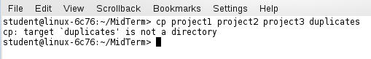
   2. combine two file row by row

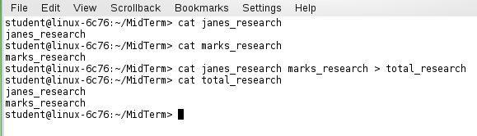

* 1. sh ProgramFood

|  |
| --- |
| sort -k1 vegetables > vsort  paste vsort bread > food  awk '{printf "%s\t%s\t%s','%s %s\n",$1,$2,$3,$4,$5}' food |

